PYTHON PROGRAMMING

Q1

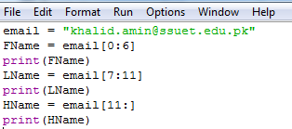

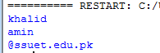

Q2

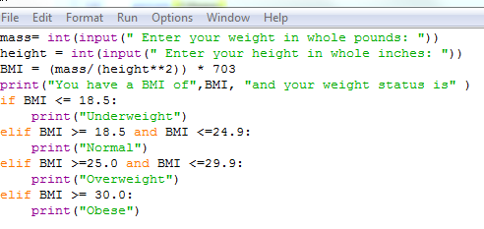

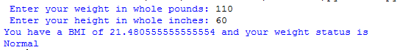

Q3

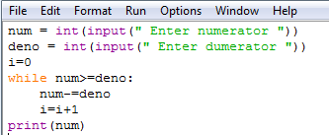

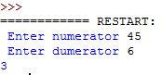

Q4

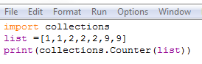



Q5

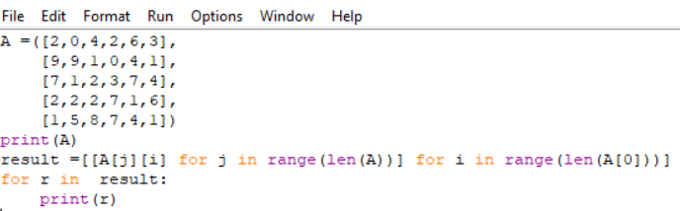

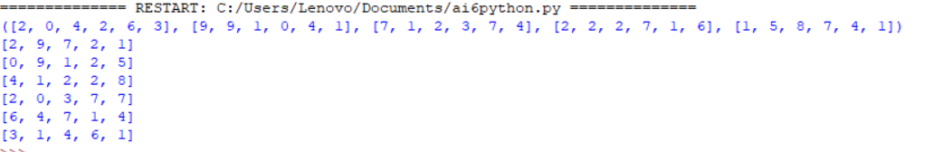

Q6

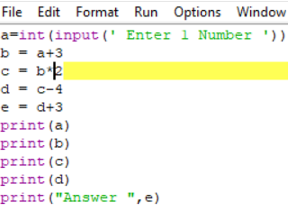

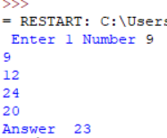

Q7

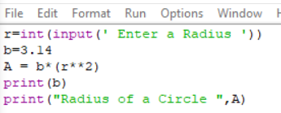

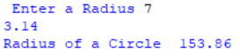

Q8

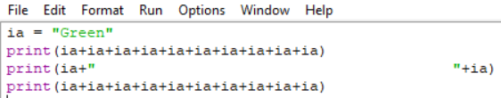

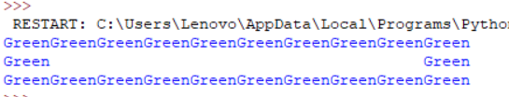

Q9

bloods = ([1,0,0,0,0,0,0,0],

[1,1,0,0,0,0,0,0],

[1,0,1,0,0,0,0,0],

[1,1,1,1,0,0,0,0],

[1,0,0,0,1,0,0,0],

[1,1,0,0,1,1,0,0],

[1,0,1,0,1,0,1,0],

[1,1,1,1,1,1,1,1])

a1 = 'O-'

a2 = 'O+'

a3 = 'A-'

a4 = 'A+'

a5 = 'B-'

a6 = 'B+'

a7 = 'AB-'

a8 = 'AB+'

blood = input("Enter Blood Type ")

if blood == 'O-' and bloods[1][0] == 1:

print("it can be donate")

elif blood == 'O+' and bloods[1][1] == 1:

print("it can be donate")

elif blood == 'A-'and bloods[1][0][1] == 1:

print("it can be donate")

elif blood == 'A+' and bloods[1][1][1][1] == 1:

print("it can be donate")

elif blood == 'B-' and bloods[1][0][0][0][1] == 1:

print("it can be donate")

elif blood == 'B+' and bloods[1][1][0][0][1][1] == 1:

print("it can be donate")

elif blood == 'AB-' and bloods[1][0][1][0][1][0][1][0] == 1:

print("it can be donate")

elif blood == 'AB+' and bloods[1][1][1][1][1][1][1][1] == 1:

print("it can be donate")

else:

print("it cannot be donate")

